Screen Shots:

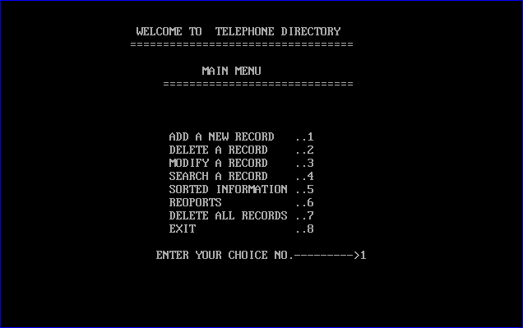

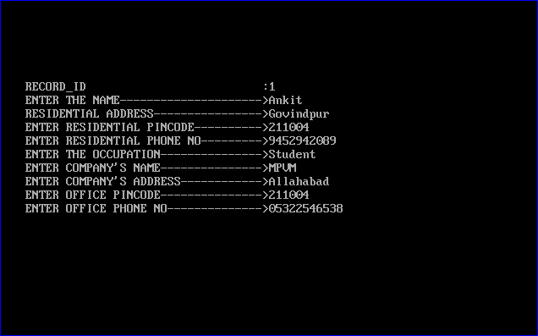 Fig.1 Main Menu

Fig.2Adding Record

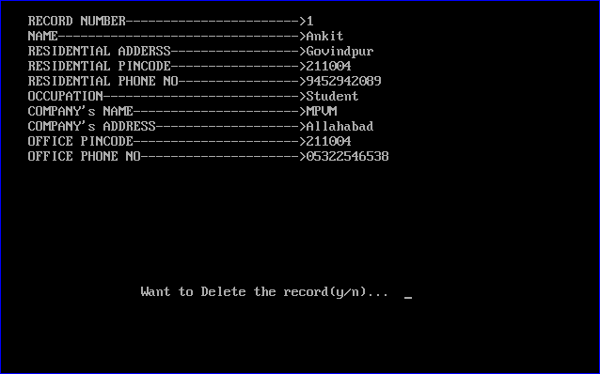

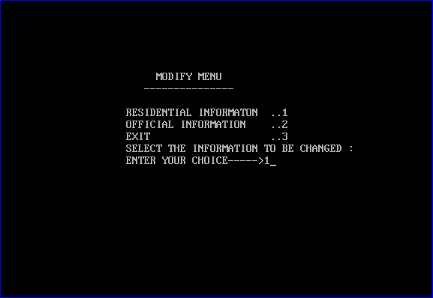 Fig.3 Deleting a record

Fig.4 Modify Menu

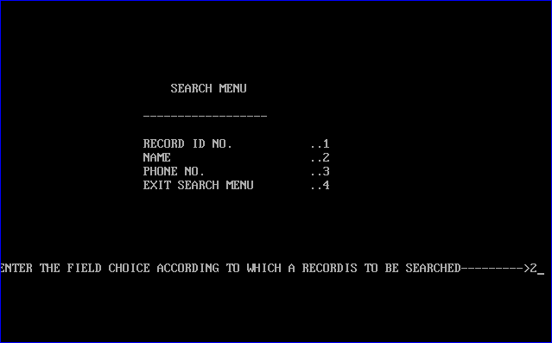

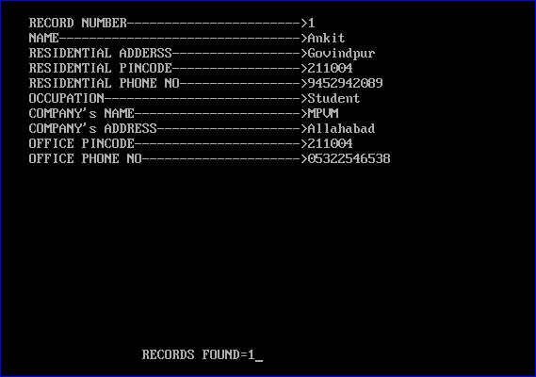 Fig.5 Search Menu

Fig.6 Fig.6 Record Found

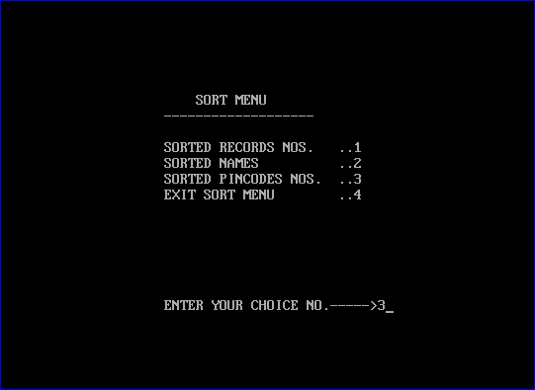

Fig.7 Sort Menu

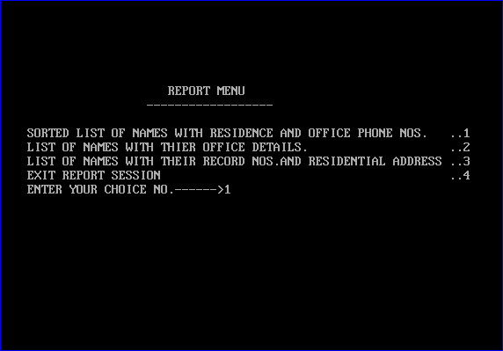

Fig.8 Report Menu

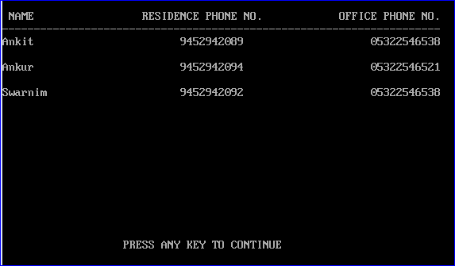

Fig.9 Report of Name, Res. Phno. And Office Phno.

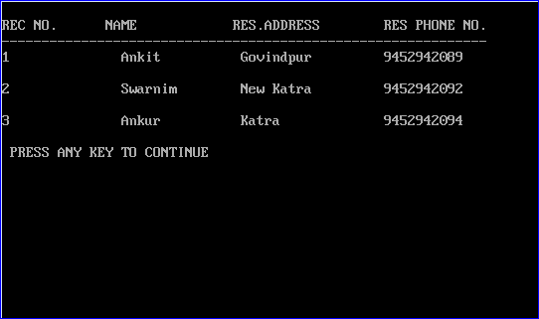

Fig.10 Report of Recno.,Name,Res. Add. and Res. Phno